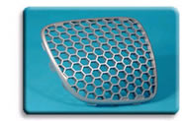
  Automotive Exteriors
  INDURE® Materials

INDURE® Polyolefin Alloys
This series of durable polyolefin materials has been designed to exhibit excellent resistance to scratch and mar, reducing damage both during processing and in the field. An ‘X’ designation indicates the product is suitable for injection molding, while an ‘E’ designation indicates a product developed for sheet or profile extrusion. For technical data, click on the specific material name in the following list:
INDURE E1500HG  INDURE E1600 | INDURE X-76  INDURE X210 | INDURE X-220

